Program Viability Committee:

Data Summary
A key mandate of the Program Viability Committee was to consult a full range of stakeholders in order to gather information and opinions on English and French language program viability in the Halton District School Board. Under the leadership of Director Stuart Miller and Associate Director David Boag, program viability feedback was sought from a full complement of stakeholder sources representing all perspectives that could be brought to the committee and examined. These perspectives were considered in concert by the Program Viability Committee over a matter of several months and were used to shape the direction of the Program Viability recommendations moving forward. Feedback from the consultation options that follow were all considered.

Public Feedback Form
Using input from several areas of the organization including planning, communications, research and school programs, the feedback form was created to capture valuable demographic and opinion-based information around the viability of English and French programing in the Halton District School Board. Further to this, the feedback form also provided an opportunity for open comments and suggestions by the individual respondent.
The survey was created using Checkbox software and the invitation was sent via a Syner-email message delivered to all parent/guardians. In addition, a link was posted from the PVC information page on the Halton District School Board general website. The feedback form was open from January 6th, 2016 through January 29th, 2016. School principals were also sent a pdf version of the feedback form which they could print and distribute to any stakeholders who wished to complete their responses on paper.
There were 2979 complete responses to the feedback form. None of the items on the survey required a mandatory response, so the number of responses varied item by item.
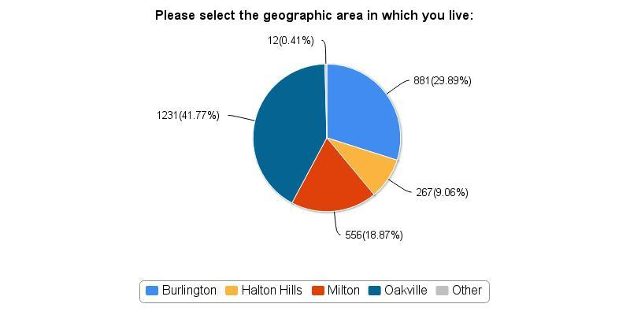
A breakdown of respondents based on geographical area.

When asked about their child’s grade range, the responses were:
Not yet enrolled in school (e.g., age 0-3.8) | 4.19%
Kindergarten (JK or SK) | 22.42%
Grades 1 to 3 | 34.47%
Grades 4 to 6 | 23.63%
Grades 7 and 8 | 7.83%
Grades 9 to 12 | 6.28%
Unsure | 0.1%
Not Applicable | 1.08%

- Of all of the respondents who indicated that their child was in elementary school:
  - 33.92% were in an English program, 63.66% were in French Immersion and 1.08% were in the extended French program.
  - Of all the respondents who indicated that their child was in secondary school:
    - 57.75% were in an English secondary program, while 37.43% were in a French Immersion secondary program and 1.6% were in an Extended French secondary program.
- 1.47% of respondents indicated that their child was an English Language Learner
- 10.39% of respondents indicated that their child had an IEP
The feedback form also contained a series of questions aimed at gathering information about preferences in overall program delivery, specifically in the areas of entry point (early entry versus mid-entry), school model (single-track versus dual-track) and intensity of language.
With regards to entry point for students into a French Immersion program, the responses from all participants who chose to respond to this item are aggregated below:
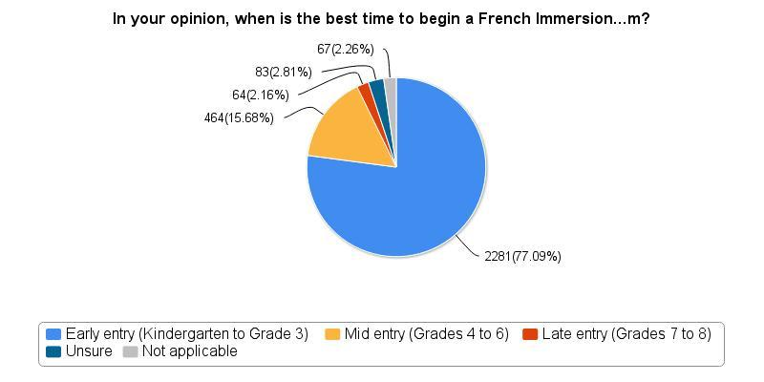
In your opinion, when is the best time to begin a French Immersion program?
With regards to preferred delivery model for an immersion program, the responses from all participants who chose to respond to this item are aggregated below:
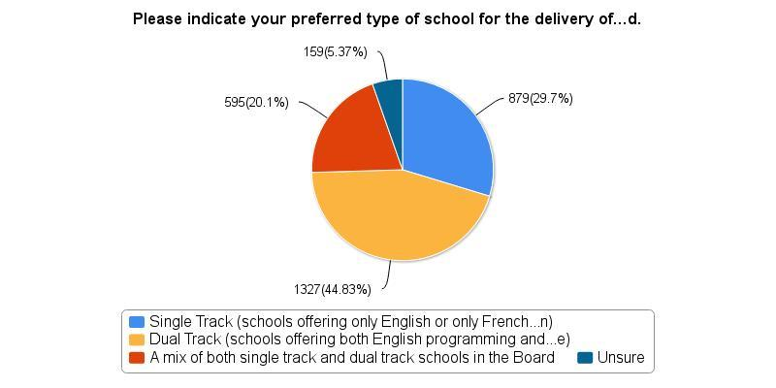
Please indicate your preferred type of school for the delivery of a language program
When asked about preferred intensity levels in an early entry French immersion program, the largest portion of respondents (59.6%) indicated that a 50% English / 50% French delivery model was most appropriate. When asked about the preferred intensity level of a mid-entry French Immersion program, the largest portion of respondents (49.3%) indicated that less than 80% intensity in French is preferred.
When asked to respond specifically to the idea of enrolment caps;
  - (22.8 / 10.9) 33.7% of all those who responded to this item agreed or strongly agreed that caps are an appropriate method of ensuring viability in English and FSL programs, whereas (22.2 / 24.8) 47.0% disagreed or strongly disagreed
  - Around some specific capping methods, there was 74.2% general disagreement to the statement: ‘Use of a lottery is an appropriate method of determining which school a student will attend for FSL’
  - Similarly, there was 60.6% general disagreement to the statement: ‘Use of first-come, first-served is an appropriate method of determining which school a student will attend for FSL program
Participants were also invited to provide additional feedback in the form of an unlimited, open text response. What follows are some general conclusions based on trends observed in the final open text opportunity in the feedback form.
These open text responses indicated:
- A very strong early entry voice
- A very strong voice for neighbourhood schools
- A very strong voice against changing the models of current schools with consideration given as to why many families relocated and/or purchased their homes in the locations where they did
- Many assumptions and some misinformation on the part of the respondents:
    - Several suggestions that the HDSB invest in strong recruiting practices to find high quality, qualified French teachers (e.g., go outside of the province)
    - Several suggestions that the HDSB review academic research around language acquisition
    - Several participants expressed anxiety about their children who are currently enrolled in a program, assuming that any future changes will impact students who are currently enrolled in programs as they exist today
- Though many respondents wondered why the feedback form does not explicitly ask about parent/guardian perceptions of the French Immersion program overall (i.e., why did you enroll your child in a French Immersion program? What is your perception of children who are enrolled in a French Immersion program?), many offered de facto opinions on this anyway, beginning several such statements with phrases like “I’ve heard from all of the parents on my street that…” or “all of the parents at my child’s school think that…”
- A strong voice for the status quo
- A strong voice for the rights of parents and students to French Immersion education, often tied to our status in Canada as a bilingual nation
- A strong voice against capping or limiting access in arbitrary or discriminatory ways, often tied to rights of the taxpayer or the rights of all children to an equitable education.

Public Focus Groups
Ipsos Reid was commissioned to conduct community focus groups between February 16th and March 10th, 2016. Over twelve sessions, 116 people participated from all over Halton [randomly selected from a group of 717 who responded to the initial invitation]. The participants all identified themselves as belonging to one of the following groups: parents of children attending single track English elementary schools; parents of children attending the French track of a dual track elementary school; parents of children attending the English track of a dual track elementary school; parents of children attending a single track French Immersion elementary school and finally, other interested and engaged parent stakeholders.
The focus groups centered discussions and feedback around three key themes: capping or limiting enrolment in a specific program, early versus mid entry into French Immersion and dual-track versus single-track French immersion schools. Feedback on the four options originally presented in the online community feedback form was also sought.
In their detailed presentations of their findings, Ipsos Reid stated that “The main objectives of the focus groups were to provide parents with an opportunity to receive more information on the challenges facing HDSB and to discuss and deliberate on the options for moving forward”. They also caution that – just as with the online feedback form - “due to the small number of people taking part and the fact that random sampling / statistical weighting have not been applied, the findings cannot be extrapolated to the population at large. This should be borne in mind when …interpreting the findings”.
Broadly shared among all parents who took part in the focus groups was the idea that capping was the least preferred option. A cap was seen as unfair; it could potentially contribute to what some perceive as existing elitism of the French Immersion community and it also could potentially divide communities. Should capping become necessary however, a first-come, first-served model for selection was seen as a more preferable option, especially in contrast to a lottery selection method.
In terms of entry point, the respondents were divided in their preference. Many parents who supported early entry also cited research showing that early exposure to languages is best. Those who supported mid-entry recognized that this option allowed for a more informed decision on the part of both parents and students in terms of learning style and the child’s potential for success.
In terms of the preferred delivery model, there was no clear consensus on whether French Immersion should be offered in a single track or dual track setting. Single track schools were seen to be better at fostering a cohesive school community, whereas dual track schools were preferred because they create and support communities around schools.

SEAC Feedback
During the month of December, Director Miller presented the Program Viability slideshow and information to SEAC. Associate Director Boag then followed up with an abbreviated presentation at the February 2016 SEAC Meeting. Following this presentation and discussion, SEAC members were asked to discuss the implications of the proposed options for Special Education students. Though members recognized the benefit of an early entry program in terms of overall exposure to a second language, several concerns were raised around the implications of early entry to French Immersion for students with special needs. It was felt that immersion programming might complicate or mask the identification of special needs of younger students, which in turn could possibly delay the arrival of accommodations and supports for students with special education needs. The possibility of a middle entry was discussed as a positive option for students who, it was felt, would develop a stronger foundation in English language skills. Additionally, later entry in French Immersion would provide more time for educators to understand the learner’s profile and needs. SEAC members also noted that a middle entry timeline aligns more favourably with psycho-educational assessments.
Dual track schools likely present fewer transitions for special education students (especially those who may transfer from one stream to the other). On the other hand, dual track schools with small cohorts in English programs produce challenges with increased need for split grades and lower diversity among the peer group. SEAC members also had questions about the consistency in the level of support from EAs and other school staff available for support in French in single track French Immersion schools.
Special Education students need to be supported and encouraged when making a choice to enrol in a French Immersion program, regardless of the delivery model. English is mandatory; French Immersion is optional; Special Education is not optional.

School Council Feedback
During the month of February, all school administrators were asked to make Program Viability a priority for their agenda. School principals were given a power-point presentation (click here) to deliver information around the issues of program viability that Halton is currently facing. After the presentation, school administrators led their school councils in discussion and feedback gathering so that the PVC could have a summary view of the perspectives of program viability from every elementary and secondary school in the Board.
Seventy elementary and seven Secondary schools provided written feedback. Among all responses, there were an overwhelming number of questions, largely centered on the process and details of any implemented change. Many school councils were in favor of an earlier entry point, as they felt that more and earlier exposure to a language is better for learning. Many elementary school councils also expressed an interest in offering core French, starting in grade 1, at all schools. Though not the majority, a significant number of elementary school councils did support a middle entry (grade 5) French Immersion model. These schools most commonly suggested that a later start in an immersion program was important to ensure that students had the appropriate skills and characteristics required to be successful in a French Immersion program.
Many school councils voiced concern over the attrition rates in French Immersion, particularly by the end of grade 12. In addition, some schools expressed concern that if the current French Immersion delivery model were to be changed too drastically, the Halton District School Board may lose students to our coterminous Board or local private institutions. Overall, school councils of both elementary and secondary schools expressed concern at how changing the current French Immersion model may change the composition of their school communities and neighbourhoods (e.g., students and families changing designated schools).

Student Senate Feedback
During the December Student Senate meeting, Director Miller spoke to the group and presented the issues around Program viability that Halton is currently facing. At the February Student Senate Meeting, Associate Director Boag followed up with an abbreviated presentation – similar to the presentations for SEAC and school councils. After the presentation, Student Senators were asked to complete an abbreviated version of the public feedback form in order to gain their opinions around program viability in Halton.
Twenty four student senators completed the feedback form. Of these responses, there was a strong preference toward an early entry point for French immersion. Generally, this group also preferred a mix of dual and single track schools for immersion programing, as in the current model, with a slight preference for purely dual track schools over purely single track schools. Half of this group disliked the idea of capping enrolment to French Immersion.

Staff Feedback
During the period from February 29th, 2016, through March 13th, 2016, all HDSB staff were invited to participate in giving their feedback to the Program Viability Committee via an online feedback form. This form collected some demographic data specific to employee groups and workplace setting; however the remainder of the items were the same as the questions found on the public feedback form.
In all, 181 complete responses to the feedback form were recorded. Of these, 72.9% identified as ETFO employees, with 7.7% identifying as OSSTF employees and 7.7% identifying as HEPA employees. The remainder of respondents were distributed in smaller numbers across all other employee groups. 46.4% of respondents indicated that they worked in a dual track setting, while 27.6% responded that they worked in a single-track French Immersion setting and 21% indicated their place of work as a single-track English school. Of all ETFO and OSSTF members who responded to this survey, 49% indicated that they provide instruction in Core French, French Immersion, or Extended French.
When asked about their preference between single track and dual track for French Immersion, respondents indicated a strong preference for single-track French Immersion (53.4%), followed by a mix of dual and single track schools and then by dual track only. When asked explicitly whether delivering French Immersion in single-track schools only would ensure the viability of both the French and the English program, 69% indicated that they believed it would.
The respondents also come out strongly in favor of early entry (66.9%) over middle entry (26.1%) for students to begin a French Immersion program. Of the early entry options, grade 1 was the most desired starting point (37.9%).
When asked explicitly about capping as a method to ensure viability of both the English and French programs in the Halton District School Board, 52% of respondents agreed or strongly agreed that capping was appropriate, whereas 35.9% disagreed or strongly disagreed. In terms of specific methods of capping however, 67.4% of all respondents disagreed or strongly disagreed with the use of a lottery to determine a student’s admittance into a French Immersion program and 64.2% disagreed or strongly disagreed with a first come, first-served method of capping.
In terms of the intensity level of a French Immersion program, 48.3% of all respondents support a 50% English / 50% French delivery model, whereas 39.8% support a greater level of French intensity in an immersion program.

Additional Feedback Presented to PVC
Over the course of the 2014-2015 and 2015-2016 school years, the Program Viability Committee frequently met and examined other sources of information and data surrounding English and French as a Second Language programming options. Some of this information examined past practices at other school districts including the Peel District School Board, the Ottawa Carleton District School Board, the Waterloo District School Board, the New Brunswick Ministry of Education, as well as the European Framework of Content and Language Integrated Learning (CLIL). In addition, the PVC was presented with comprehensive information around the current and future staffing needs and recruiting strategies in place at the Halton District School Board. More information on these resources is available from the Program Viability Committee or through the HDSB Research Department.

